Dominic Drury

10/01/2024

CS-470

5-3 Assignment: Using the Database

Three test runs for Part One: QuestionWithoutFilter, QuestionWithFilter, and AnswerWithoutFilter

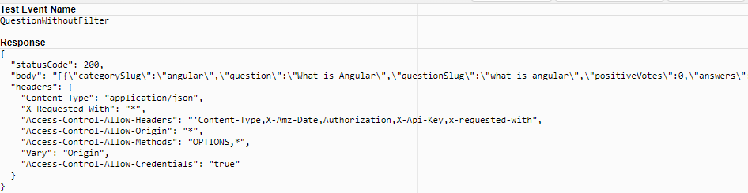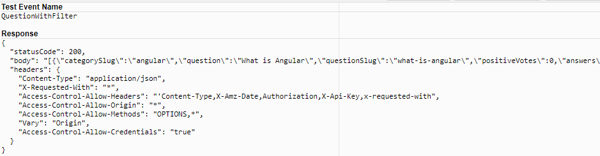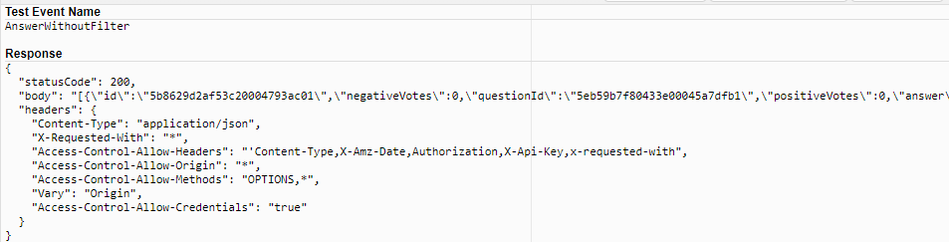

Two test runs for Part Two: TestGetQuestion and TestGetAnswer

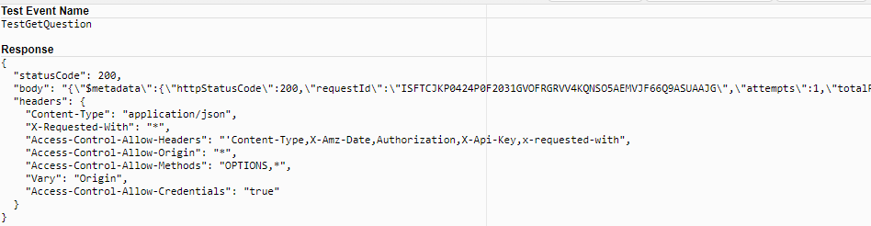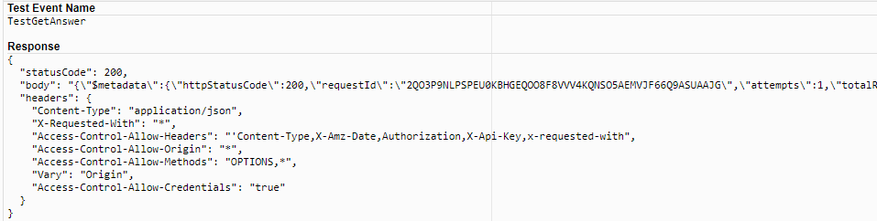

The directory structure and index.js file in the Lambda window for UpsertQuestion and UpsertAnswer

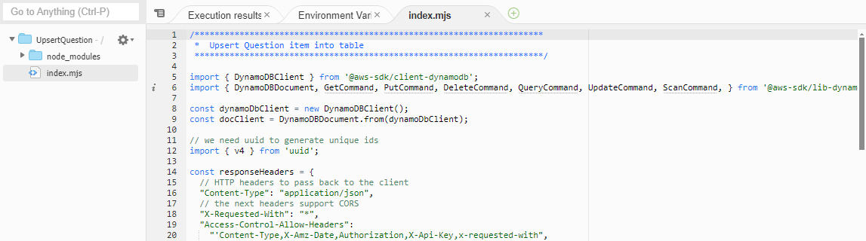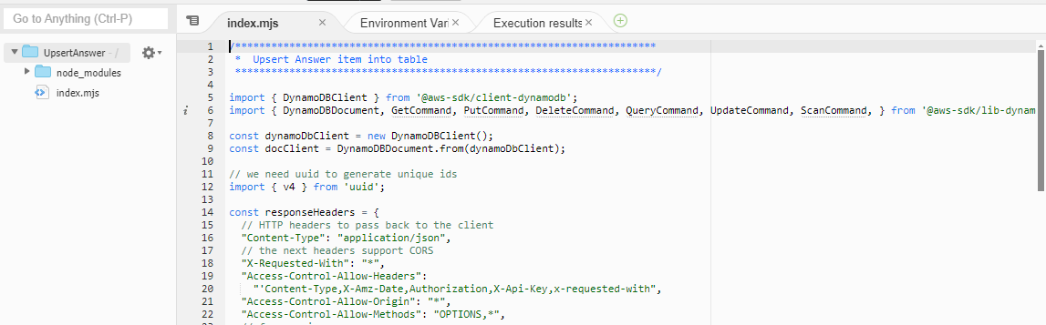

Two test runs for Part Three: TestInsertQuestion and TestInsertAnswer

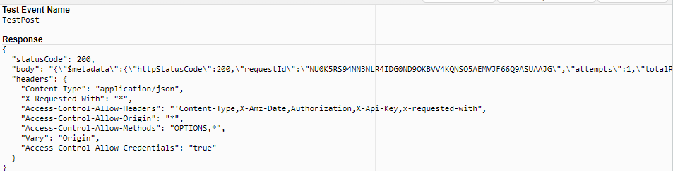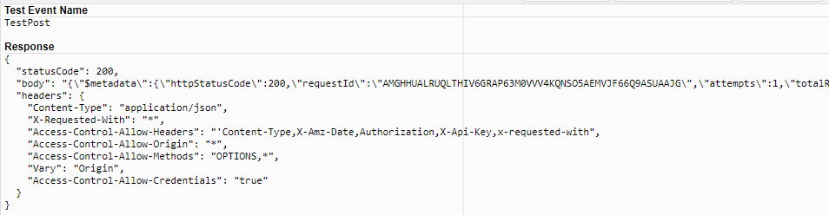

Two test runs for Part Four: TestDeleteQuestion and TestDeleteAnswer

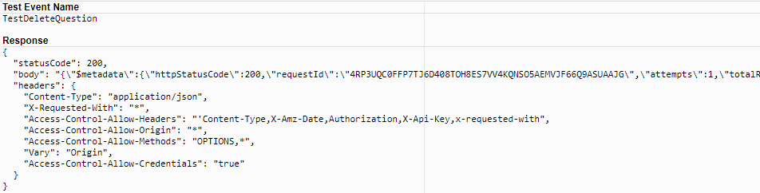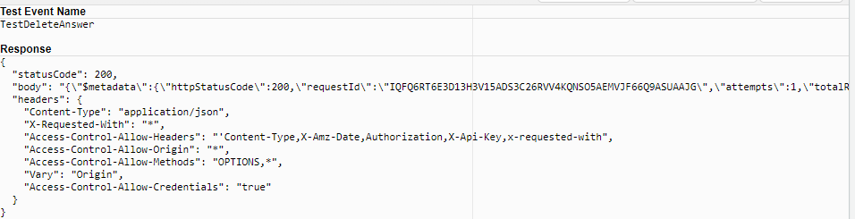

JSON policy

